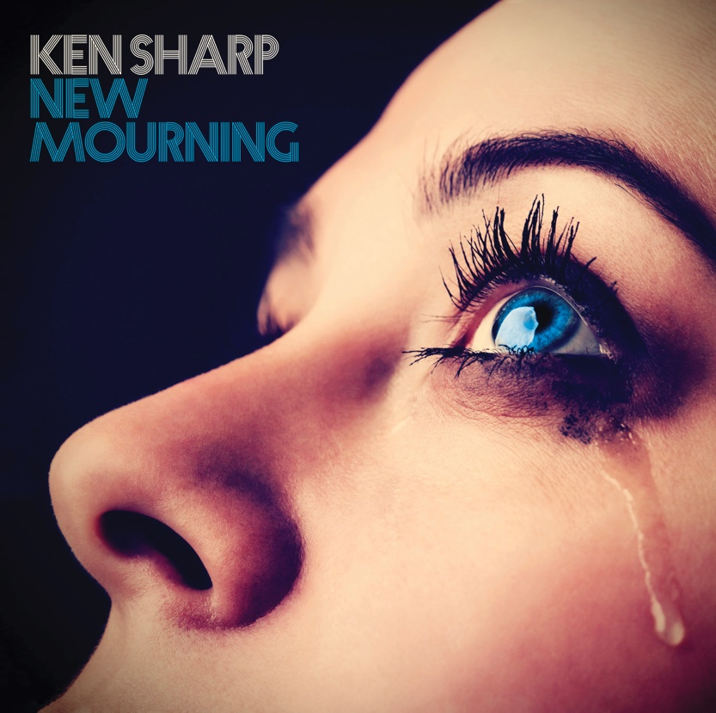

Ken Sharp—New Mourning

New Mourning is a 14-track song cycle navigating the beauty in darkness, loss and regret. From the torrid power pop muscle of “Dynamite and Kerosene,” “Burn & Crash,” and “Bad News” to the fragile intimate ballads “1000 Guitars” and “Haunts Me,” the album is a consummate sonic journey that leaves its share of musical blood on the tracks.

“My co-producer Fernando Perdomo has described the record as ‘the feel-bad album of the year, but in a good way,’” said Sharp, “and that’s an apt description. The darkness and emotional turmoil I‘ve gone through in the last few years are laid bare on the record.”

Produced by Sharp and Fernando Perdomo—whose credits include work by Todd Rundgren and Jakob Dylan—the record showcases musical contributions from Rick Springfield (“Burn & Crash,” “Satellite”), guitarist Wally Stocker of the Babys (“Dynamite and Kerosene,” “Loser”) bassist Prescott Niles of the Knack (“Mr. Know It All,” “Dynamite and Kerosene”) and keyboardist Jimmy Waldo of New England (“Satellite”) alongside the team of Perdomo and gifted musicians Rob Bonfiglio (Wanderlust/Wilson Phillips) and Ritchie Rubini (the Caulfields).

New Mourning is Sharp’s fourth album and his first in nine years. His last CD, Sonic Crayons, received raves in USA Today and garnered a four-star review in MOJO magazine, with writer Mat Snow championing Sharp as a shining light in the world of power pop.

HEAR MORE:

“With his new CD, Ken continues to explore the essence of power pop, this time with a harder edge, and some fine guitar and vocal work from Rick Springfield. He's also found a new depth and confidence in his lyric writing, his voice and his production on this new recording. It's his best work yet!" —Eric Carmen

"New Mourning is a tour-de-force delivering perfectly blended driving guitar riffs with beautiful pop melodies. Highly recommended." —Pat Prince/Goldmine magazine

About Ken Sharp:

Ken Sharp is a New York Times best-selling writer who has authored or co-authored more than 18 music books, contributes to a variety of national music magazines, works on music documentaries and has done liner notes for releases by Elvis Presley, Sly and the Family Stone, Janis Joplin, Small Faces, Santana, Cheap Trick and others.

For more information contact: sharpk@aol.com

http://www.ken-sharp.com/

Buy on CD: http://ken-sharp.com/new-mourning/
Buy on iTunes (Digital): https://itunes.apple.com/us/album/new-mourning/id1123757286
Buy on Amazon (Digital): https://www.amazon.com/New-Mourning-Ken-Sharp/dp/B01H43UHDK/
Buy on Bandcamp (Digital): https://kensharp.bandcamp.com/album/new-mourning

Reviews of "New Mourning":
From HUFFINGTON POST

“…on New Mourning, Sharp crafts deeper layers of pain and emotion that at first may seem incongruous within the jangly and hook laden melodies that have become his trademark. But pay close attention and you’ll realize that those seemingly simplistic chords can actually be deeply dramatic and jarring, making them perfectly appropriate frames to hold the gut wrenching honesty of the lyrics. The album explores styles beyond power pop, seamlessly connecting straight ahead rock ’n roll to glam pop to soul. But truth be told it is those irresistible, sugarcoated chords of his that suck you in the hardest and make you stay the longest. It’s a flag that Sharp carries proudly and fondly and this time out, based on the reactions, it seems like he has struck old school AM gold.” Chris Epting
Read full story/review – HERE http://www.huffingtonpost.com/chris-epting/the-power-of-pop----ken-sharp-releases-new-mourning_b_11763830.html

from GOLDMINE magazine...

"A year-end top 10 contender, for sure. Grade: A...New Mourning, however, is much more than simply another Ken Sharp album: the 14-track song cycle, which chronicles some of the ups and downs in Sharp's life over the past few years, is by far the pinnacle of his musical career thus far." John M. Borack

Read full review – HERE http://www.goldminemag.com/blogs/ken-sharps-new-mourning-filled-pop-music-delights

from INK 19...

"...a 14-song pop tour de force…. delivers delightful twists at every musical turn - bombarding listeners with hypnotic melodies that sound so gosh-darn happy, that one might actually miss some of the deeper and darker lyrical messages - he's sneaky like that." Christopher Long

Read full review – HERE
http://ink19.com/2016/07/magazine/music-reviews/ken-sharp

from POPDOSE

“…The melodies crackle throughout the 59-minute affair. Fans of Sweet, Cheap Trick, Rick Springfield, Marshall Crenshaw and Material Issue will find plenty to love here.” Keith Creighton

Read full review – HERE
http://popdose.com/late-summer-2016-roundup/

from CLASSICALITE

“The prettiest piece of power pop in years comes via singer/songwriter Ken Sharp on New Mourning. Beatlesque, with visions of the Raspberries swimming in his head, Sharp, throughout these 14 beautifully crafted gems, maintains a high level of pure listenability…” Mike Greenblatt

Read full review - HERE
http://www.classicalite.com/articles/40749/20160708/blogarrhea-autobahn-bernie-mora-fab-sotti-ken-sharp-paul-simon-al-lerman-rule.htm

from NO DEPRESSION

“…New Mourning offers reason for celebration…it’s his clear love of a pure pop essence that finds these melodies ringing with such richness and authority…New Mourning is awash in an unabashed celebratory spirit and, dare we say, a wholly sense of genuine joy.” Lee Zimmerman

Read full review – HERE
http://nodepression.com/album-review/new-mourning-offers-reason-celebration

from MUSIC CONNECTION

“…a power pop maestro…the album evokes the yin and yang of power pop: sweet melodies, catchy hooks/choruses and sometimes a bubblegum vibe” Daniel Siwek

Read full story –HERE
http://www.musicconnection.com/artist-profile-ken-sharp/

from NEW NOISE MAGAZINE

“…4 stars…. a near-perfect full length of hook-happy, memorable tunes. The Philadelphia native draws inspiration from the classics, The Beatles and The Raspberries, to more modern peers like Jellyfish all the while managing to put his own groove in the sound. It’s almost irrelevant to call out the standout tracks here, as there is not a weak one among the 14, but “Bad News,” “Burn & Crash” and “Dynamite & Kerosene” all come off like instant classics. If he keeps churning out albums like this one, some new Power Pop chronicler will have to come along and write the definitive book on Ken Sharp one day.” John Moore

Read full review –HERE
http://newnoisemagazine.com/album-review-ken-sharp-new-mourning/#

from STEPHEN K PEEPLES

“…melodic, hook-filled power chords, layers of jangling guitars and stacked vocal harmonies, and dark lyrics borne of a good relationship gone bad…to these ears – still ringing with those perfect little sonic masterpieces created during the first generation power pop, when I was in my early teens – “New Mourning” warrants repeated listenings. ‘Scuse me while I dive in for another.” Stephen K. Peeples

Read full story – HERE

http://stephenkpeeples.com/news-and-reviews/ken-sharp-new-mourning-bright-power-pop-with-a-dark-side/#.V8HoKZgrK70

from THE AQUARIAN

“…filled with pop/rock-infused gems…Sharp’s ability to move up and down the vocal pathway is like harmonious clockwork. Seamless and sonically pleasing, there isn’t a bad tune in the whole bunch. It’s a winner.” John Pfeiffer
Read full review – HERE
http://www.theaquarian.com/2016/07/27/shoreworld-ken-sharp-new-mourning/

from INNOCENT WORDS

…”Sharp shines a light of beauty and hope with his words…upbeat instrumentation which has a strong lineage to ’60s Brit pop, the sparkle of the Posies, and the hint of grit of New York Dolls…Sharp flexes his love for indie pop charisma…” Troy Michael
Read full review – HERE
http://innocentwords.com/ken-sharp-new-mourning-self-released/

from ABSOLUTEPOWERPOP

“New Mourning is 14 tracks of solid gold and also a clear contender for Best of 2016…” Stephen Ferra
Read full review – HERE http://absolutepowerpop.blogspot.com/2016/07/early-july-roundup.html

From GOLDMINE “QUICK PICKS”
…”Imagine Matthew Sweet’s songwriting acumen with a production almost as clean and energized as ELO. What you have is Ken Sharp coming into his own as a singer/songwriter on this new solo album.” Pat Prince

Read full review – HERE http://www.goldminemag.com/blogs/ken-sharps-new-mourning-filled-pop-music-delights

from ROCKWRITEBLOGSPOT

“… Masterful musical touches enhance Sharp's smart song craft…a power pop celebration that doubles as a concept confessional of his own jaunt through life's highs and lows over the past few years…” Robert Kinsler

Read full review – HERE
Http://rockwrite.blogspot.com/

from POWERPOPAHOLIC

“…Easily this makes my top ten list, the best Sharp’s ever sounded and if it takes another decade to follow up, I’ll be waiting with open ears….” Aaron Kupferberg
Read full review – HERE http://www.powerpopaholic.com/2016/07/ken-sharp-and-siberian-death-crash.html

from PURE POP RADIO...

"...a towering achievement….these songs emit a joyous sound.” Alan Haber

Read full review – HERE https://purepopradio.com/tag/ken-sharp/

from POWER POP NEWS…

“…With Sharp’s top-notch song writing, New Mourning’s’ soaring harmonies and fine musicianship, this latest release is a real winner.” Rich Rossi “

Read full review – HERE http://powerpopnews.com/2016/cd-review-ken-sharp-new-mournings/

from POWER OF POP
…”his songs channel the authentic spirit of pop-rock, power pop and retro-pop while lyrically express the pain of loss and regret…A sharp (!) distillation of ALL that is timeless and excellent about ageless classic pop-rock. Recommended.” Kevin Matthews

Read full review – HERE http://www.powerofpop.com/album-review-ken-sharp-new-mourning/

from GLORYDAZEMUSIC
...”catchy, infectious tunes with a real feel good factor to them, the listener is guaranteed to have a beaming smile on their face after spinning this beauty. there is not a misstep anywhere to be found, ….this album is a little ray of sunshine in what has been a pretty grim year music wise…a sure fire top 5 placing when it comes to my end of year list.” Malcolm Smith
Read full review – HERE http://gdm.glorydazemusic.com/articles.php?article_id=6318

From POPGEEKHEAVEN
“Ken finds his mojo, and puts it all together in an unstoppable power pop freight train. The opening track, “Dynamite & Kerosene,” compares to the Raspberries’ “Go All The Way” for sheer hook-laden exuberance…”
Five stars.
http://www.popgeekheaven.com/music-discovery/bloody-red-baron-september-reviews

